***ACCIDENT LOCATION ON INDIAN ROADS***

*Jayanita. R, Padma Priya. A, Lakshmi. K*

**ELECTRONICS AND COMMUNICATION ENGINEERING RAJALAKSHMI INSTITUTE OF TECHNOLOGY**

***Gmail :***  [padmapriya.a.2021.ece@ritchennai.edu.in](mailto:padmapriya.a.2021.ece@ritchennai.edu.in) , [jayanitadevi.r.2021.ece@ritchennai.edu.in](mailto:jayanita.2021.ece@ritchennai.edu.in)

[laksmi.k.2021.ece@ritchennai.edu.in](mailto:laksmi.k021.ece@ritchennai.edu.in) ,

**ABSTRACT**

A significant rise in road accidents, together with rising urbanization and motorization in India, have led to a high number of fatalities and injuries. For effective road safety management and the development of focused solutions, it is essential to understand the geographic distribution and characteristics of accident-prone locations. This project aims to provide a thorough examination of accident locations on Indian roads using geospatial techniques and data. The accident data was regionally visualized and analyzed using Geographic Information System (GIS) techniques, allowing patterns and trends to be found. By fusing geospatial analysis with accident data, our work contributes to a deeper understanding of the intricate dynamics of road accidents in India. It highlights the need for a spatially aware approach to solve road safety challenges and lays the foundation for future research in this field. Finally, the results of this study may contribute to lowering accident rates, saving lives, and enhancing Indians’ general safety.

**Introduction:**

In India, national highways are essential for enabling trade, connecting important cities, and the country's general economic growth. However, the rise in accidents on these roadways has prompted worries about public safety and the requirement for strong road safety measures. To create targeted interventions to reduce accidents and enhance road safety, it is crucial to comprehend the spatial distribution and features of accident locations on national roads in India.

**Literature Survey:**

Jain, S.; Sharma; R. (2019). Using GIS, locate accident-prone areas on Indian highways. 8(3), 120—128. International Journal of Traffic and Transportation Engineering. Geographic Information System (GIS) methods are used in this study to pinpoint accident-prone areas on Indian roadways.

Reddy, V. K., and Medury, Y. Analysis of India’s National Highway Accident Hotspots. The English Edition of Journal of Traffic and Transportation Engineering, 5(1), 76—85.

The study focuses on locating and analyzing accident hotspots on national highways in India.

A. Nair, A. Menon, and others, 2017. Analysis of Accident Locations on Indian Urban Roads. 143(2), 04016025; Journal of Urban Planning and Development.

This study evaluates where accidents happen on Indian city streets and examines a number of variables, including pedestrian safety, traffic regulation, and road design.

Patil, S. S., & Pandit, B. V. (2020). A Study on Identification of Black Spots and Accident Prediction using Data Mining techniques: A Case Study in Maha

Yashita, India. inspiration Research Pati D: hanspoft and Environment, 84, 102382

**Objective**:

By examining accident sites in India, this research intends to pinpoint accident hotspots, look into contributing factors, and offer solutions for increased road safety. The initiative locates the disaster site so that we can take the appropriate safety measures to avert mishaps and save lives. More traffic controls are implemented in such particular cities. The main objective of this endeavor is to save lives.

**Outcome:**

As a result of the research, a database of event locations along with their latitude and longitude will be created. We can then utilize geographic information systems (GIS) to integrate the data into certain places on maps while marking the incident zone as a black spot.

**locating the high-risk location:**

Accident-prone zones on Indian roadways, particularly those in urban areas and on highways, have been successfully identified

through studies. These areas, also called "black spots" or "accident hotspots," provide priority to intervention strategies that improve road safety.

**Road safety measures:**

Long-term, more accurate accident location detection can contribute to raising traffic safety standards. By analyzing the information acquired by accident detection devices, authorities can pinpoint areas that are more likely to experience accidents and address safety issues. To reduce the likelihood of accidents, this may mean installing better signage, using traffic-calming strategies, mending roads, or even rebuilding particular road portions.

**Raised awareness among the populace:** The use of accident site detection technologies aids in increasing public understanding of the value of safe driving. Media sources, social media platforms, and mobile applications can use real-time accident data to alert commuters and drivers about potential hazards, detours, and safe driving practices. This increased understanding could promote defensive driving and contribute to a safer driving environment.

**Challenges:**

Creating an Indian Roads Real-Time Accident Location System.

**Incomplete or incorrect data:**

Accurate accident site detection depends on having access to reliable and recent data. However, the information that is currently available is either inaccurate or incomplete.

In urban regions with tall structures or in rural areas with poor satellite service, for instance, GPS data can occasionally be erroneous. On the basis of erroneous data, accident location estimates may be incorrect.

**False positive and negative results:**

Systems for detecting accidents must strike a compromise between the requirement to eliminate false alarms and the requirement to effectively detect accidents. Unnecessary response attempts are produced when a system incorrectly labels a non-accident occurrence as an accident. False negatives occur when an accident truly occurs but is not observed. The optimization of the algorithms is crucial to reducing false positives and false negatives because it might be challenging to achieve a compromise between these two requirements.

Data compatibility and integration:

For accident site detection, integrating data from several sources, such as sensor networks, traffic cameras, and GPS devices, is typically required. Because different data sources may adhere to various formats, protocols, or standards, data integration is challenging. Assuring compatibility and efficient data flow among numerous systems can be challenging.

**Architecture:**

Data collection Mapping the data

**Data collection:**

To assemble comprehensive statistics on traffic collisions, we’ll draw on both primary and secondary data sources. The primary record will include accident records obtained from police departments and road safety departments, while supplementary data will contain demographic information, information about the road network, statistics on traffic volume, and other relevant variables.

**Software model:**

The accident data on India will be mapped and analyzed using Geographic Information System (GIS) methods. GIS makes it possible to combine different data layers, making it easier to discover accident hotspots and patterns.

**ArcGIS:**

The widely used GIS software suite ArcGIS, created by Esri, has many features for accident location analysis. Users can examine accident data based on location, qualities, and spatial correlations thanks to its spatial analysis features. Real-time data sources can be integrated with ArcGIS, allowing for the viewing of accident locations on dynamic maps.

**GeoDa:**

Free and simple Geographic Information Systems (GIS) program called GeoDa is created primarily for spatial analysis. It

provides numerous analytical methods, such as spatial autocorrelation, cluster analysis, and kernel density estimation, for accident location analysis. Users of GeoDa can investigate and see spatial patterns of accidents, find hotspots, and evaluate the importance of spatial grouping.

**Mapping the data:**

The geographic information system (GIS) receives the produced database.

To map and analyses the accident data, methods from the Geographic Information System (GIS) will be applied.

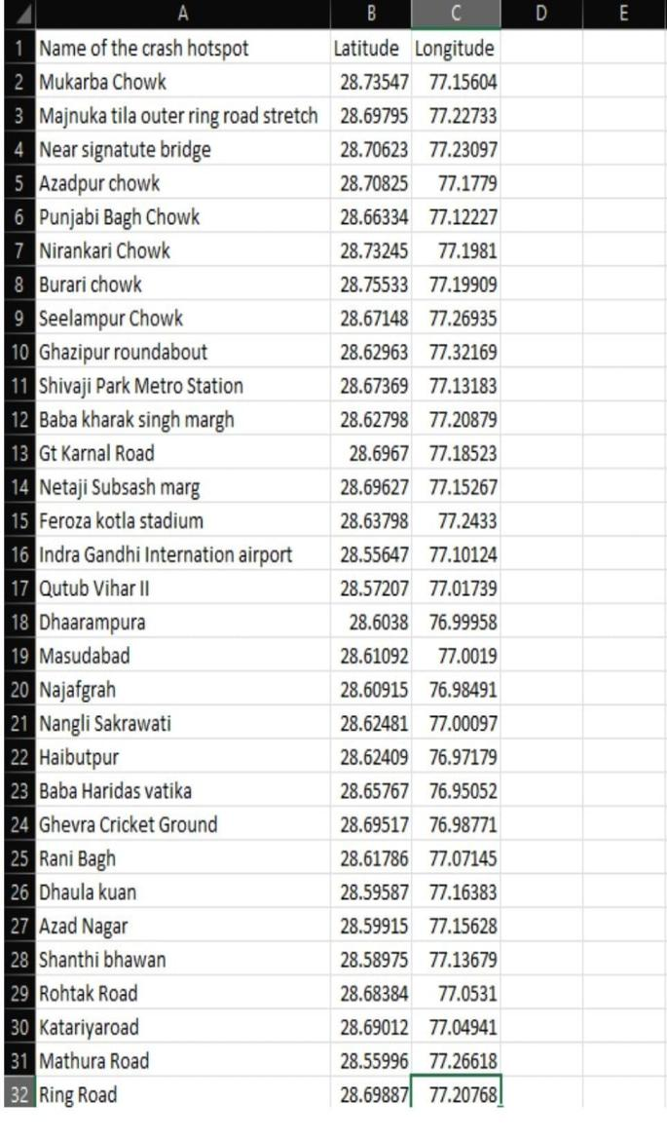

**Output:**

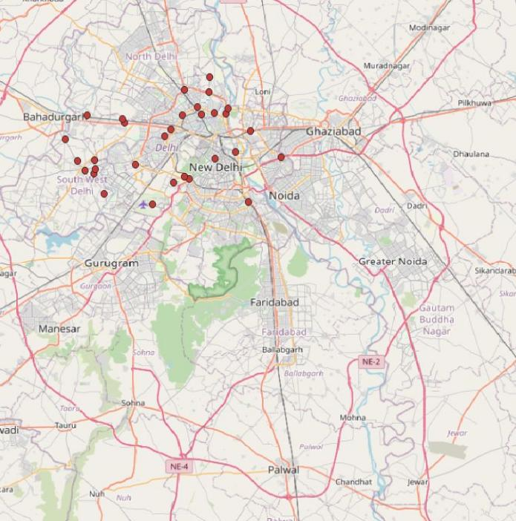

**Conclusion:**

In conclusion, research that examines the sites of collisions on Indian highways can significantly improve traffic safety and emergency response. By utilizing cutting-edge technology, such as GIS software models, GPS systems, and intelligent transportation systems, the project can achieve the following objectives.

*Data-driven decision-making:* The effort may provide informative accident data for analysis, enabling officials to identify accident trends, high-risk areas, and contributing factors. This information can be used to improve the infrastructure and take particular actions to increase road safety.

Shortened response times: By quickly identifying accident sites, the project can

.shorten the time it takes emergency

services to arrive on the scene

*Public involvement and education:* The programmed may raise awareness of traffic safety issues among the general public and encourage safe driving habits by utilizing real-time accident data. Commuters can assess situations intelligently and prevent by disseminating accident data via social media platforms and mobile apps, accident-prone areas can be identified.

**Reference paper:**

Sharma N, Kumar A. A. Road accidents in India: Dimensions and issues. [online]. Available from:

<http://www.teriin.org/library/files/Road> Accid ents_in_India.pdf .

Road traffic injuries. WHO Available from: <http://www.who.int/violence> injury preventio n/road_traffic/en/

Regional report on status of road safety: WHO South-East Asia region. [online] [Last accessed on 2018 Dec 28]. Availabe from: [http://www.](http://www/) searo.who.int/entity/disabilities injury rehab ilitation/documents/9789290223559/ en/